Minor Project Report
Exploratory Data Analysis of Biological Health Datasets Using Computing Techniques
Project Category: Research
Projexa Team Id-26E1159 - Dots and Dashes
Submitted in partial fulfilment of the requirement of the degree of
BACHELOR’S OF COMPUTER APPLICATIONS (AI/ DS)
Semester-II
to
K.R Mangalam University
by
Raghav Gupta (2501060043) Section-A
Kanishk Grover (2501060071) Section-A
Dev Sehgal (2501060066) Section-A
Prakriti Yadav (2501060061) Section-A
Aarohi Kalsi (2501060152) Section-A

Under the supervision of
Mr. Digvijay Singh
<Internal Mentor>


Department of Computer Science and Engineering
School of Engineering and Technology
K.R Mangalam University, Gurugram- 122001, India
April 2026

DECLARATION

I hereby declare that this project report is my original work and has not been submitted elsewhere. The information presented here is true and correct to the best of my knowledge.

Raghav Gupta (2501060043)
Kanishk Grover (2501060071)
Dev Sehgal (2501060066)
Prakriti Yadav (2501060061)
Aarohi Kalsi (2501060152)

CERTIFICATE

This is to certify that the Project entitled, “Exploratory Data Analysis of Biological Health Datasets Using Computing Techniques” submitted by “Raghav Gupta (2501060043), Kanishk Grover (2501060071), Dev Sehgal (2501060066), Prakriti Yadav (2501060061) and Aarohi Kalsi (2501060152)” to K.R Mangalam University, Gurugram, India, is a record of bonafide project work carried out by them under my supervision and guidance and is worthy of consideration for the partial fulfilment of the degree of Bachelor of Technology in Computer Science and Engineering of the University.

<Signature of Internal supervisor>
Mr. Digvijay Singh
Supervisor

Dean SOET
Dr Pankaj Agarwal, Dean SOET

Date:

INDEX

S No | Content | Page No
 | Project Completion Certificate | 3
 | Abstract | 5
 | Introduction (description of broad topic) | 6
 | Motivation | 7
 | Literature Review/Comparative work evaluation | 8
 | Gap Analysis | 11
 | Problem Statement | 12
 | Objectives | 13
 | Methodology | 14
 | Experimental Setup | 17
 | Results And Discussion | 20
 | Conclusion & Future Work | 26
 | References | 27
 | Annexure I: Plagiarism Report | 28

ABSTRACT
As for computer application in general, data analysis holds significance in understanding data collected. Health datasets hold structured information regarding various diseases and population health which can be easily understood using computers. This project will employ the use of computing and data analysis skills to analyze biological health data of India in order to discover any disease trends. The key idea in this project is to explore health data of India using computing methods such as processing, visualizing, and analysis.

The project employs secondary biological health data sourced from NDAP and applies data cleaning, organizing, visualizing, and analysis processes computationally. It was discovered that Acute Respiratory Infection was the most common disease with about 145 million cases in India while Acute Diarrhoeal Diseases were second. As far as mortality is concerned, Pneumonia and Acute Respiratory Infection were the most common. There were also observed gender disparities regarding disease incidence and mortality, which indicated a huge disparity between disease occurrence and mortality rates each year.

KEYWORDS: Data Analysis, Disease Patterns, Public Health, Python, Pandas, Data Visualization

Chapter 1
Introduction

- Background of the project

Rapid urbanization, economic liberalization, and the evolving way of life affect public health. The incidence of diseases in any nation is intricate and varies by state, year, and demographic group, including male versus female patients. Recognizing such disease trends is imperative to help policymakers allocate resources and develop strategies that improve population health.
Traditionally, analyzing health trends involved compiling the data manually and applying basic statistical approaches. However, the introduction of computational data analysis enables more accurate and timely analyses. With Python language, it is possible to clean, aggregate, and visualize the collected data to uncover trends that would otherwise be impossible to detect using other approaches. Therefore, it is necessary to conduct such analysis for making evidence-based decisions and improving health care service delivery.
Data science can revolutionize health care because most countries have digitized patient medical records and other sources of public data. Hence, it is possible to use this resource to generate insights into health trends, identify the main areas that need intervention, and predict potential outcomes for future planning. In the current project, I will focus on an available dataset that includes data on several diseases in different Indian states from 2010 to 2022.

- MOTIVATION

The health of the populace is the backbone of any nation's productivity and success. In a country with different states and numerous people such as India, the types of diseases prevalent are vastly varying depending on various factors such as gender and time. Although the Indian government has a lot of information collected by entities such as the NDAP, most of the information tends to lie dormant in its unstructured form. The impetus behind this project is that there is a need for this data to be made meaningful.

Cases of both communicable and non-communicable diseases are increasing. However, since there is no proper analysis of this information, policymakers are making decisions intuitively. From preliminary examination of the data, we can identify that there is a massive difference between the numbers of cases and the number of deaths recorded from the diseases. There are also significant gender discrepancies where males seem to be dying more frequently. This needs to be analyzed computationally for better insight.

The motivation behind this project comes from the wish to employ recent computer science knowledge—data cleaning, data aggregation, data visualization—using Python in order to reveal hidden insights and patterns in the data available. The analysis will focus on several key metrics: disease frequency (Acute Respiratory Infections, Diarrhoeal Diseases), death rate (Pneumonia), as well as year-over-year change due to special events (COVID-19 effects on the number of reported cases).

The main idea is to progress from merely organizing the information in Excel-like tables. We are motivated to create an analysis framework, which would allow us to determine what diseases need the highest amount of public funding, what demographics are the most affected and how public health emergencies influence regular health statistics collection. In the end, we hope to demonstrate how computer science can help to improve the lives of many people all around the world.

Chapter 2

LITERATURE REVIEW

- Review of existing literature
1. Deep Learning in Mining Biological Data
The latest technologies used in data acquisition devices provided life sciences with the opportunity to generate multimodal data in various biological application fields. Data that have been classified into three main categories (images, signals, and sequences) are very large and complex. Data mining of this large volume of data for pattern identification is no doubt very challenging; it involves the utilization of sophisticated machine learning processes that require intensive handling of data. Machine learning models with artificial neural networks have proven effective in identifying patterns, while their deep models called deep learning (DL) have been widely applied to solve several challenging pattern identification problems. To understand the impact of DL (particularly its architecture types) on biological data mining in the three aforementioned categories, a meta-analysis has been carried out and the results critically analyzed. Moreover, a comparison study on the use of these tools is presented, considering qualitative, quantitative, and benchmarking approaches. Lastly, several issues that could be addressed in future studies regarding mining biological data using DL are proposed, along with various future directions.
- Machine Learning Meta-analysis of Large Metagenomic Datasets: Tools and Biological Insights
Metagenomic shotgun sequencing of the human-associated microbiome offers an abundance of microbial signatures for predicting and discovering biomarkers for human diseases or health conditions. Nevertheless, the application of high-resolution microbial signatures brings novel difficulties, and reliable computational algorithms for learning tasks are still unavailable. Furthermore, there is insufficient validation of classifiers in external samples, raising concerns regarding the generalizability of the disease predictive models. In this work, we review methods for metagenomics-based prediction and the quantitative evaluation of the strength of associations between the microbiome and phenotype. We also present a computational framework for predicting tasks based on quantitative microbial signatures, which can include both relative abundances at the species level and strains' specific genes. An extensive meta-analysis with special attention to generalizability across cohorts was conducted on a set of 2424 publicly accessible metagenomic datasets from eight large scale studies. Good disease prediction performance was observed for cross-validation in all cases, but, in general, was enhanced with feature selection as well as using markers for strains rather than taxa at the level of species. Disease prediction models applied from one study to another performed less effectively compared to the within-study cross-validation. However, incorporating the healthy samples from other studies into the dataset resulted in increased disease prediction potential. It seems that certain bacterial species (mainly Streptococcus anginosus) represent generalized dysbiosis of the microbiome and not its relation to any disease.
- Big Biological Data: Challenges and Opportunities

The “Omics” Era in Life Sciences involves data presentation in diverse forms which reflect the biological information at multiple levels, such as genomic data, transcriptomic data, epigenomic data, proteomic data, metabolomic data, molecular imaging data, molecular pathway data, population data, and medical record data. Biological data are voluminous; even the amount of information in biological datasets is already beyond petabyte (PB) and is heading towards exabyte (EB). No one questions the potential of biological data to generate enormous value, provided that scientists surmount the obstacles along the way, like the management of complex information, integration of data from extremely diverse sources, adoption of certain guiding principles or standards in dealing with big data. Tools and techniques for biological big data analysis can help us turn an enormous amount of information into knowledge regarding fundamental biomedical processes, which can then be used for translational or personalized medicine.

- Topic modeling for cluster analysis of large biological and medical datasets

None more fittingly deserves the big data label than to refer to the ever-growing size and complexity of biological and medical data sets. Novel approaches must be sought out to enable hypothesis generation and testing, interpret results biologically, and develop validated predictors. While clustering analysis may help analysts determine clusters within their variable set, clustering algorithms have been shown to perform increasingly poorly with large numbers and/or hyper dimensions of data. Topic modeling belongs to the category of machine learning research that has been primarily developed as an analysis tool that enables structured exploration of large sets of documents. Topic modeling's ability to lower large dimensions into a smaller set of latent variables can help solve problems associated with clustering in large biological and medical data sets.

- The impact of commercial health datasets on medical research and health-care algorithms

Health care is entering an entirely new phase where technology such as cloud computing, distributed computing, and artificial intelligence play important roles. This makes health care data an exclusive commodity that serves both the private and public sectors. The systems used in collecting and distributing data related to health care, regardless of whether they come from industry, academic, or governmental institutions, are far from perfect, and they cannot maximize the possibilities of any research efforts made later down the line. In this Health Policy paper, we highlight the state of health care data vendors, focusing particularly on the source of their data, issues involved with reproducibility and generalization of data, and ethics surrounding data vending. There should be sustainable ways to manage open-source health care data, ensuring that all global populations can contribute to the field of biomedical science research. However, this process will require collaboration among key stakeholders who will ensure that health care data become more available, diverse, and representational for everyone without violating anyone's privacy.1. Mahmud, M., Kaiser, M. S., McGinnity, T. M., & Hussain, A. (2021). Deep learning in mining biological data. Cognitive computation, 13(1), 1-33.
2. Pasolli, E., Truong, D. T., Malik, F., Waldron, L., & Segata, N. (2016). Machine learning meta-analysis of large metagenomic datasets: tools and biological insights. PLoS computational biology, 12(7), e1004977.
3. Li, Y., & Chen, L. (2014). Big biological data: challenges and opportunities. Genomics, proteomics & bioinformatics, 12(5), 187-189.
4. Zhao, W., Zou, W., & Chen, J. J. (2014). Topic modeling for cluster analysis of large biological and medical datasets. BMC bioinformatics, 15(Suppl 11), S11.
5. Alberto, I. R. I., Alberto, N. R. I., Ghosh, A. K., Jain, B., Jayakumar, S., Martinez-Martin, N., ... & Celi, L. A. (2023). The impact of commercial health datasets on medical research and health-care algorithms. The Lancet Digital Health, 5(5), e288-e294.

- GAP ANALYSIS

While conducting various researches related to disease patterns, many studies have been conducted either globally or on particular diseases which gained widespread media attention like the coronavirus pandemic or malaria. However, there are very few studies which encompass long-term, thorough investigations of a variety of diseases in all states and union territories of India and also account for gender differences and trends based on years. This study addresses these points through data-driven analysis regarding disease patterns and fatalities and identifies key areas of focus.

- PROBLEM STATEMENT

Datasets generated from public health studies tend to be bulky, carrying lots of data that may not be easy to understand or derive meaning from just by looking at them. Using conventional approaches on analyzing such data will be highly inefficient and may cause the analyst to miss out on important insights.

A methodical and computational way of processing biological health data needs to be found so that important information could be extracted from it. There is a need for data analysis tools that will make the task easier for the user by automatically cleaning data and providing relevant statistical summaries and visualizations. This kind of analysis will be very effective in determining key public health concerns.

- OBJECTIVES

To apply programming and data analysis concepts to real-world biological datasets

To collect and manage biological health data using computational tools

To perform exploratory data analysis using statistical and visualization techniques

To identify disease-related patterns through data interpretation

To improve practical understanding of data handling and analysis using programming

CHAPTER 3: METHODOLOGY
The methodology section outlines the procedures and methods used to implement this project.

3.1 Overall architecture /Flow chart:

The overall architecture of the project follows a standard data analysis pipeline, from data acquisition to insight generation.

Step 1: Data Collection.

The data for health issues was collected from the National Data and Analytics Platform (NDAP), which provided an unstructured CSV file containing the raw dataset.

Step 2: Data Preparation (Cleaning)

For cleaning the dataset, I developed a Python code using the Pandas library. In the process, I made the column names more intuitive, dropped any row with missing data on gender, and filled any remaining missing data on Cases and Deaths using the mean value of the entire column.

Step 3: Data Analysis and Visualization

After cleaning, the data set was analyzed using summary statistics for total cases and deaths. Further, the dataset was grouped based on disease type, year, and gender for visualization using tools such as bar graphs and line plots.

Step 4: Interpretation and Reporting

Lastly, the visualizations were interpreted to derive conclusions.

3.2 Data Description
- Source of Data: The data set used in this study was collected from the National Data and Analytics Platform (NDAP) by the Indian Government (https://ndap.niti.gov.in). This is an open-source data set that contains case numbers and death rates in India.
- Collection of Data: The data collection process is done by the Indian Government from different public health data records from all the states and union territories. The collected data range from the year 2010 to the year 2022.
- Type of Data: This is a tabulated data with categorical data (Country, State, Gender, Type Of Disease) and numerical data (Cases, Deaths). It is also time series data since there is a 'Year' feature in the data table.
- Size of Data: The original data set has 36,335 data points and seven columns of features. However, after data cleaning, which involved removal of rows without 'Gender', the new size is 18,443 rows of data.
- Format of Data: This data set is saved in CSV file format.
- Data Cleaning: The following processes have been performed to clean up the raw data using a python script named 'clean.py':
- Renaming Columns: This involves renaming the columns to simpler versions such as 'Type Of Disease' is renamed to 'DiseaseType'.
- Dealing with missing values: Rows in which the ‘Gender’ variable contained missing values were removed. As for the variables ‘Cases’ and ‘Deaths,’ missing values were replaced by the mean of their respective columns.
- Checking Data Types: Made sure that all numeric variables are recognized as numeric.
- Quality Check of the Dataset: The data obtained from NDAP is an officially provided source of information; thus, it can be considered reliable to some extent. The removal of missing values is the main quality check performed on the data. The main drawback is that the information may be understated, particularly for 2020, because of the COVID-19 pandemic.
- Data Variables: The key variables in the dataset are:
- Country: Name of the country (India for all rows).
- State: Name of the Indian state or union territory.
- Year: The calendar year of the report.
- Gender: Gender of the patient (Male, Female).
- DiseaseType: The name of the disease.
- Cases: The number of reported cases.
- Deaths: The number of reported deaths.

Chapter 4

Implementation
- Explanation of how the project was implemented.
- Algorithms, code, or design schematics.
- Issues encountered during implementation and how they were solved.

The project was developed using Python programming language by making use of various useful libraries that help in manipulating and analyzing data.

Step 1: Environment Setup
The development was done in Visual Studio Code. The required packages were installed in Python via pip:

• pandas for manipulating data.

• numpy for performing numerical calculations.

• matplotlib for making static visualizations.

Step 2: Data Loading and Initial Cleaning
The raw dataset was read into a Pandas DataFrame. Data exploration was performed with the help of df.info() and df.head()..

Code Snippet (from clean.py):
import pandas as pd
import numpy as np
df = pd.read_csv('Health Dataset.csv')

print("original dataset info:")
print(f"shape: {df.shape}")
print(f"missing values:\n{df.isnull().sum()}\n")

Step 3: Data Preprocessing
- Column Renaming: Column names were simplified for easier access.
newColumnNames = {
'Country': 'Country',
'State': 'State',
'Year': 'Year',
'Gender': 'Gender',
'Type Of Disease': 'DiseaseType',
'Cases (UOM:Number), Scaling Factor:1': 'Cases',
'Deaths (UOM:Number), Scaling Factor:1': 'Deaths'
}
df.rename(columns=newColumnNames, inplace=True)

- Handling Missing Values: Rows with missing 'Gender' were dropped. Missing 'Cases' and 'Deaths' were filled with the column mean.
df = df.dropna(subset=['Gender'])

if df['Cases'].isnull().sum() > 0:
cases_mean = df['Cases'].mean()
df['Cases'] = df['Cases'].fillna(cases_mean)

- Saving Cleaned Data: The cleaned DataFrame was saved to a new CSV file for analysis.
output_file = 'Health Dataset Cleaned.csv'
df.to_csv(output_file, index=False)

Step 4: Exploratory Data Analysis and Visualization

The cleaned dataset was analyzed to answer specific questions. This involved grouping data and creating plots.
- Total Cases and Deaths: Simple aggregations were performed.

total_cases = df['Cases'].sum()
total_deaths = df['Deaths'].sum()

- Most Prevalent Diseases: Cases were grouped by 'DiseaseType' and summed.
- Most Fatal Diseases: Deaths were grouped by 'DiseaseType' and summed.
- Gender Analysis: Cases and deaths were grouped by 'Gender' to identify disparities.
- Year-wise Trends: Cases and deaths were grouped by 'Year' to see changes over time.

Challenges and Solutions:
- Challenge 1: The dataset was huge and had multiple rows where 'Gender' was not specified.
- Solution: Rows that did not have information for 'Gender' were removed because it was an important category for analysis purposes. The decrease in size of the dataset was acknowledged.
- Challenge 2: In some numerical columns, there were missing numbers (NaN), which could make computations impossible.
  - Solution: This was resolved by using the fillna() function, which substituted NaN with the mean value of the entire column. It is a common procedure in data analysis.
- Challenge 3: The range for ‘Cases’ and ‘Deaths’ included many orders of magnitude, which made some of the visuals hard to interpret.
  - Solution: The analysis involved data aggregation (sum) and good visualizations with labels.

Chapter 5

RESULTS AND DISCUSSIONS

Analysis of the cleaned data set showed various significant insights in regard to diseases prevailing in India.

1. OVERALL DISEASE SPREAD:
- Total reported cases across all diseases and years ≈ 229.8 million.
- Total reported deaths ≈ 51,593.
- There exists a massive difference between cases and deaths, which implies that the prevalence of diseases in the country is much higher than their lethality.

2. MOST PREVALENT DISEASES (CASES):
- Acute Respiratory Infection dominates with ~145M cases.
- Followed by:
  - Acute Diarrhoeal Diseases with ~45M
  - Typhoid with ~7.9M
  - Neonatal Tetanus with ~4.4M
  - Cholera with ~4M

Conclusion: Respiratory and waterborne diseases account for most public health problems in the country.

3. MOST FATAL DISEASES (DEATHS):
- Pneumonia (All Causes) → Highest deaths
- Acute Respiratory Infection → 2nd highest
- Acute Diarrhoeal Diseases → 3rd

Insight: Despite being among those diseases whose prevalence is not necessarily high, there exist some types of diseases that claim relatively many lives (e.g., pneumonia).

4. GENDER-BASED INSIGHTS:
- Cases: Males had a slightly higher number of cases than females.
- Deaths: Males had significantly higher deaths (~60% of total deaths).

Conclusion: Men seem to have a higher exposure to risk factors or may be less prone to visit clinics in the earlier stages of the disease than women.

5. YEAR-WISE TREND:
- Cases increased from 2017 → 2019, then dropped in 2020.
- Deaths, however, consistently increased, peaking in 2020.

Interpretation: A sharp decrease in cases can be explained by either poor registration of cases or an overloaded healthcare system. The increasing number of deaths means the deterioration of the quality of healthcare.

VISUALIZATIONS:

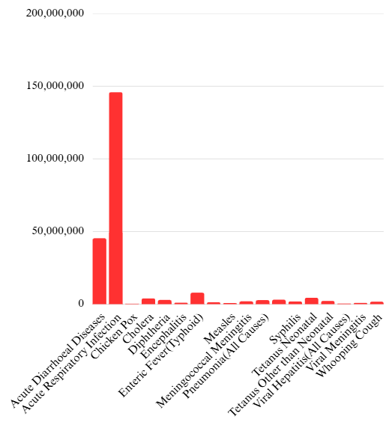

Figure 1: Disease Type vs Cases

As can be seen in the bar graph above, Acute Respiratory Infection has much higher case numbers than any other disease.

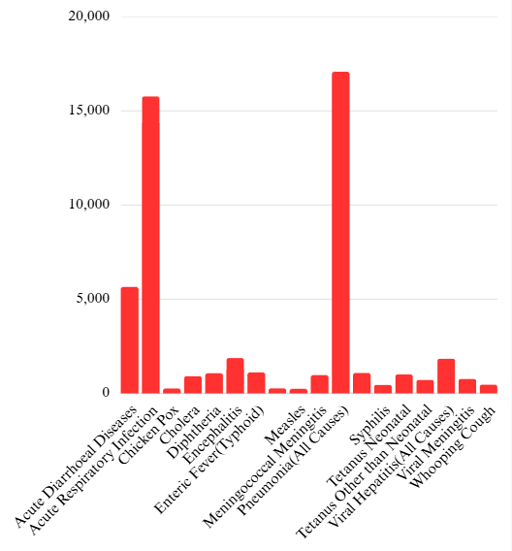

Figure 2: Disease Type vs Deaths

In the graph above, even though there are lots of cases of ARI, there have been more deaths caused by Pneumonia than others.

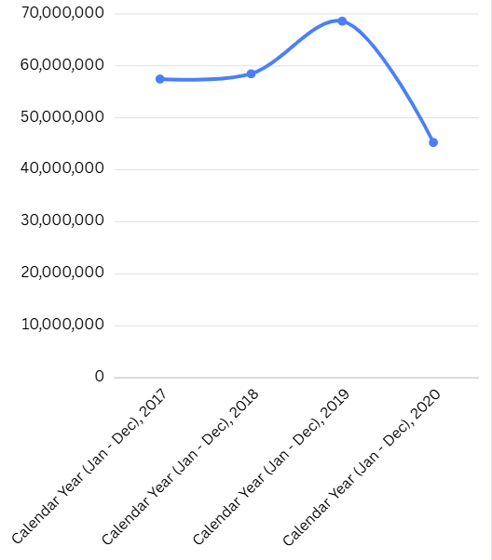

Figure 3: Cases vs Year

As it can be seen in the graph above, the total reported cases peaked at the year of 2019 and then sharply decreased in 2020.

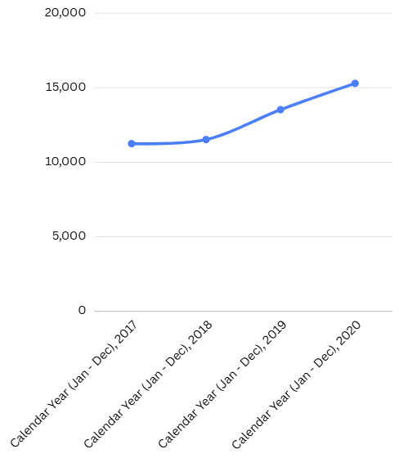

Figure 4: Deaths vs Year

As can be seen in the figure above, the graph shows an increasing trend over the years for reported deaths, with the peak year being 2020.

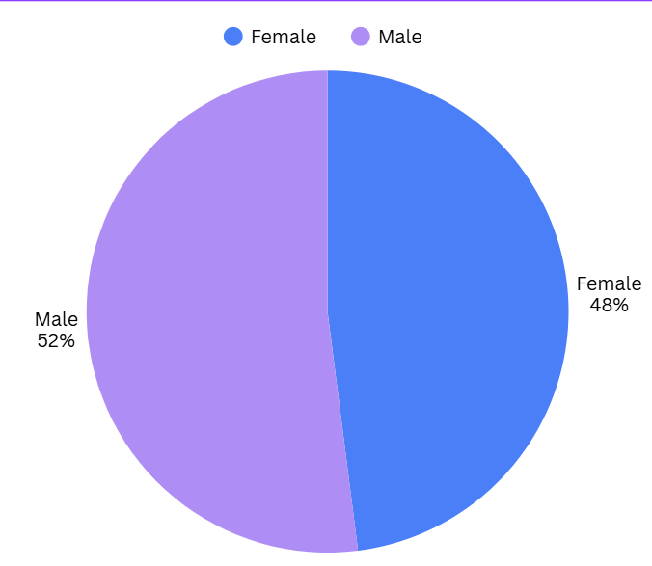

Figure 5: Gender vs Cases

The pie chart above displays the comparison between male and female cases.

Chapter 6

FUTURE WORK

This project was successful in analyzing a large health dataset to uncover some disease trends. Possible ways of developing the project in the future are:
- Predictive Modeling: Applying machine learning algorithms to predict future cases and deaths associated with different diseases through time series models like ARIMA or LSTM models.
- Geographical Analysis: Combining the data on the state level with geolocation data to identify the regions where specific diseases occur more often.
- Correlation Analysis: Researching any possible relationships between the prevalence of certain diseases and environmental conditions, such as the quality of air, sanitation, and population density.
- Web Application: Creating a web application that would allow people to filter the data by disease, year, and state.

CONCLUSION
Recently, there has been a need for data-based decision making in matters concerning public health. In this case, analyzing large scale public health data becomes a necessity in understanding the disease burdens, population at risks, and the formulation of health policies accordingly.
For this project, data analysis techniques were utilized to extract relevant information from a large Indian health dataset. The important results from this include:
- Premier health burden: The commonest diseases in India are respiratory infections such as ARI and pneumonia, and water borne infections such as Acute Diarrhoeal diseases.
- Comparison between mortality rate and prevalence rate: There exists a discrepancy between the prevalence of a disease and the mortality rate. In this case, although ARI had the largest number of patients, Pneumonia was the highest killer disease.
- Disease burden and gender: Men tend to suffer more compared to women in terms of disease burden. Moreover, men have higher mortality rate.
- COVID-19 pandemic in the year 2020: The data suggests that the disease caused a reduction in the total number of patients suffering from other infections but deaths continued to increase.
This project shows how computational techniques can help in the simplification and understanding of biological data.
REFERENCES
- McKinney, W. (2010). Data Structures for Statistical Computing in Python. In Proceedings of the 9th Python in Science Conference (pp. 51-56).
- Hunter, J. D. (2007). Matplotlib: A 2D graphics environment. Computing in Science & Engineering, 9(3), 90-95.
- Virtanen, P., et al. (2020). SciPy 1.0: fundamental algorithms for scientific computing in Python. Nature Methods, 17, 261-272.
- Government of India. (n.d.). National Data and Analytics Platform (NDAP). Retrieved from https://ndap.niti.gov.in.

ANNEXURE I:

Plagiarism Declaration Certificate

Title of Work: Exploratory Data Analysis of Biological Health Datasets Using Computing Techniques
Submitted By: Raghav Gupta (2501060043), Kanishk Grover (2501060071), Dev Sehgal (2501060066), Prakriti Yadav (2501060061) and Aarohi Kalsi (2501060152)
Institution: K. R. Mangalam University, Gurugram
Department: SOET
Date of Submission:

I hereby declare that the work entitled,” Exploratory Data Analysis of Biological Health Datasets Using Computing Techniques” submitted for academic evaluation and research purposes is my original work. I confirm that:
- I have acknowledged and properly cited all sources, references, and data included in this work.
- This work does not contain any material previously published, written, or prepared by another person, except where due acknowledgment has been made.
- I understand that plagiarism is an academic offense and a violation of research ethics. Any breach of this declaration may lead to disciplinary action as per university policies.
- I have used appropriate referencing techniques and maintained academic integrity throughout this work.

I affirm that the submitted work has normal plagiarism less than 10% and free from AI content.

⸻

Signature of Student: __________
Date: __________

